Hurricane Carrots

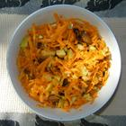

Ingredients:
1 cup shredded carrots  1 cup finely chopped apple  1/2 cup raisins  1/2 cup golden raisins | 1 cup whole almonds  1/2 cup greek yogurt  salt and ground black pepper  to taste
Directions:
1. | Toss carrots, apple, all raisins, and almonds with greek yogurt in medium  bowl. Season to taste with salt and pepper.

