Cinnamon Ants on Sticks

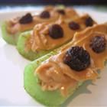

Ingredients:
1 large stalk celery, cut into 3 pieces  3 tablespoons peanut butter or nutella | 1 teaspoon ground cinnamon  2 tablespoons raisins
Directions:
1. | Place the celery pieces on a clean surface, hollow part facing up, and sprinkle evenly with cinnamon. Spoon peanut butter or nutella into the hollow, and arrange raisins on top.

