Cheesy Broccoli & Potato Soup

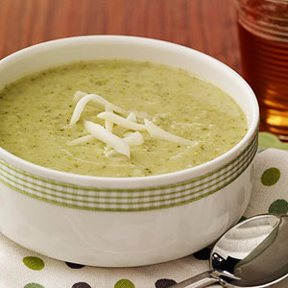

Servings: 4
Ingredients
- 2 teaspoons olive oil
- 1/2 onion, chopped
- 1 medium potato, peeled and diced into 1/2-inch pieces
- 3 cups broccoli, chopped
- 3 cups low-salt vegetable stock
- 1 cup reduced-fat Monterey Jack cheese, shredded

Directions
In a large stockpot, heat oil and saute the onion for 5 to 7 minutes over low to medium heat. Add potatoes, broccoli, and stock; bring to a boil. Reduce to a simmer and cook, covered, for 12 to 15 minutes or until broccoli and potatoes are tender when pierced with a fork.
Remove the mixture from stove top; allow to cool a bit. Pour the mixture and cheese into a blender; puree. (Or use a handheld blender to do it right in the stockpot.)

