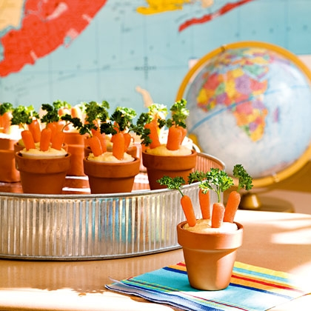

CARROT PATCH

What you'll need
- Hummus
- Baby carrots
- Curly parsley

How to make it
- For each patch, spoon about 3 tablespoons of hummus into a small plastic cup (ours were 3-ounce size).
- Shortly before you're ready to deliver the snack to the classroom, gather four baby carrots for each cup and use a toothpick to poke a hole in the top of each one. Insert a sprig of parsley into each hole.
- Then plant the carrots in the hummus. For a special presentation, you can place the cups in mini terra-cotta pots that the kids can take home and use to start veggie seedlings of their own.

