Broccoli Grape Salad

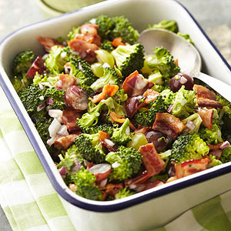

Yield: 10 to 12 side-dish servings
Prep Time: 30 mins

Ingredients
- 1 pound bacon, cut into 1-inch pieces
- 1 cup mayonnaise or salad dressing
- 1 cup red and/or green seedless grapes, halved
- 1/2 cup finely chopped red onion
- 1/4 cup sugar
- 7 cups fresh broccoli florets (1 large head)
Directions
In a large skillet, cook bacon over medium heat until crisp. Drain bacon on paper towels and set aside.
In a large bowl, stir together mayonnaise, grapes, red onion and sugar. Add broccoli and two-thirds of the bacon; stir to coat. Cover and chill in the refrigerator for at least hours or up to 24 hours. Store remaining cooked bacon, covered, in the refrigerator. Sprinkle remaining bacon over salad just before serving. Makes 10 to 12 side-dish servings.

