Balsamic Glazed Carrots

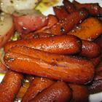

Ingredients:
3 cups baby carrots  1 tablespoon olive oil  1 1/2 tablespoons balsamic vinegar | 1 tablespoon brown sugar
Directions:
1. | Heat oil in a skillet over medium-high heat. Sauté carrots in oil for about 10 minutes, or until tender. Stir in balsamic vinegar and brown sugar, mix to coat and serve.

